**Data Structures and Algorithms**

**Lab Report**

**Lab12**



|  |  |
| --- | --- |
| Group Members Name & Reg #: | **Muhammad Haris Irfan**  **(FA18-BCE-090)** |
|  |  |
| Class | Data Structures and Algorithms CSC211 (**BCE-3B**) |
| Instructor’s Name | Dilshad Sabir |

**In Lab Tasks**

**Task:1**

**Complete the function ‘void insert_node (int x, struct heap_struct * H)’ in the**

**skeleton code provided.**

**Solution:**

The code is shown below,

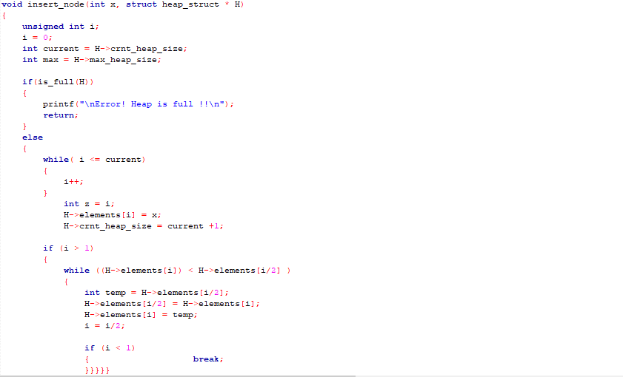

The Result of the following code is attached below:

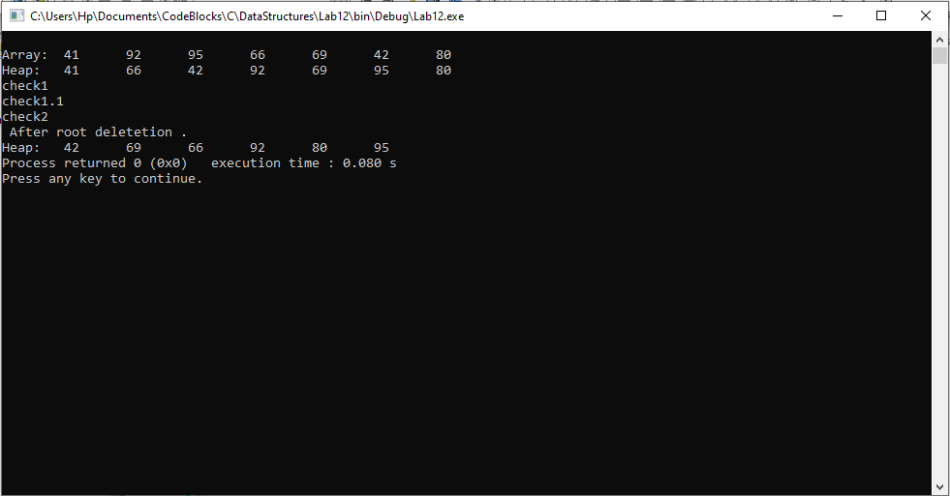

-------------------------------

**Task:2**

**Complete the function ‘void delete_root (struct heap_struct * H)’ in the**

**skeleton code provided.**

**Solution:**

The code is shown below,

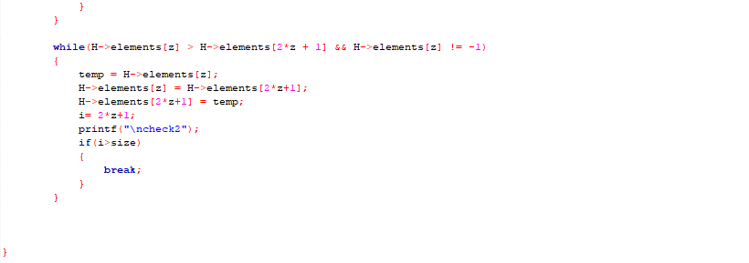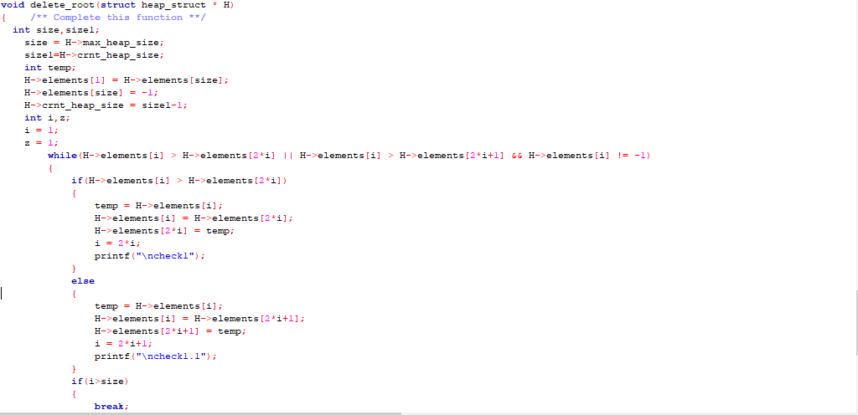

The Result of the following code is attached below:



-------------------------------

**Post Lab Task.**

**Task 2:**

Study Binomial Heaps and Fibonacci Heaps

Solution

Binomial Heap

A Binomial heap is a data structure that acts as a priority queue but also allows pairs of heaps to be merged together, they are implemented as a set of binomial trees.

Fibonacci Heap

A Fibonacci heap is a collection of trees satisfying the minimum-heap property, that is, the key of a child is always greater than or equal to the key of the parent. This implies that the minimum key is always at the root of one of the trees. Compared with binomial heaps, the structure of a Fibonacci heap is more flexible.

------------------------------

**Conclusion:**

In this lab, we completed the insertion and deletion function of a Binary Heap, furthermore we also studied Binomial and Fibonacci Heaps and the difference between them.

------------------------------

THE END